**Model.**

Parameters:

$R_{i }$: *Raw material required for running process $i$ for 1 hour, $where i∈\left(1,2\right)$*

$L_{i}$: *Labor required for running process $i for 1 hour$, $where i∈\left(1,2\right)$*

$A_{ci }$: *Amount of ingredient $c produced by process i when run for 1 hour$, $where i∈\left(1,2\right), c∈(1,2)$*

$P_{y }$: *Selling price of chocolate $y$, $where y∈\left(1,2\right)$*

*L: Labor availability*

*R: Raw material availability*

$M_{cy }$: *minimum fraction of ingredient $c$ to be present in chocolate $y$, $where y∈\left(1,2\right), c∈(1,2)$*

Decisions:

$x_{i}$: *Number of hours to run process $i$, $where i∈\left(1,2\right)$*

$z_{cy }$: *Amount of ingredient $c$ to be used in chocolate $y$, $where y∈\left(1,2\right)$, $, c∈(1,2)$*

Calculated Parameters:

$P_{c}$: *Amount of ingredient $c produced$, $where c∈\left(1,2\right)$*

$P_{c}= \sum_{i}{A_{ci}}$ $x_{i}$

$N_{y }$*\**

: *Ounces of chocolate $y$, $where y∈\left(1,2\right)$*

$N_{y }= \sum_{c}{z_{cy}}$

Objective: *Maximize Revenue*

$max\sum_{y∈( 1,2)}{ }$ $N_{y}$ ${ P}_{y}$

*

Constraints:

$\sum_{i}{x_{i }}* R_{i }≤R \left(1\right)$ Raw material availability

2) Labor availability

$z_{cy }{≥ M_{cy }* N}_{y}$ (3) Ingredient proportions required in each chocolate

$\sum_{y}{z_{cy }}≤ P_{c}$ (4) Availability of Ingredient $c$

${x_{i}, z}_{cy }≥0$ (5) Non- negative hours and ounces to be allocated

Notes:

1. Constraint (1) and (2) ensures that the number of hours process 1 and 2 is run takes into account the available raw material and labor required to run the processes
2. Constraint (4) ensures that the total amount of a particular ingredient distributed among both the chocolates do not exceed the availability of the ingredient, which is produced by running the processes 1 and 2.
3. Constraint (3) ensures that units of each chocolate type has the required percentage of ingredients mentioned. It is important to denote this equation in a linear format, i.e., a decision variable cannot be present in a denominator of the fraction. It is natural to write this constraint as $\frac{z_{cy }}{N_{y }}≥M_{cy }$,which is a non-linear representation, since a decision variable is present in the denominator. To convert this to the linear format, simply move this denominator to the right-hand side of the equation to get constraint (3). Below the implications of a linear and non-linear representations when using simplex solver is illustrated. It is important to note that the simplex solver computes the optimal solution by checking only the boundary points of the feasible region.

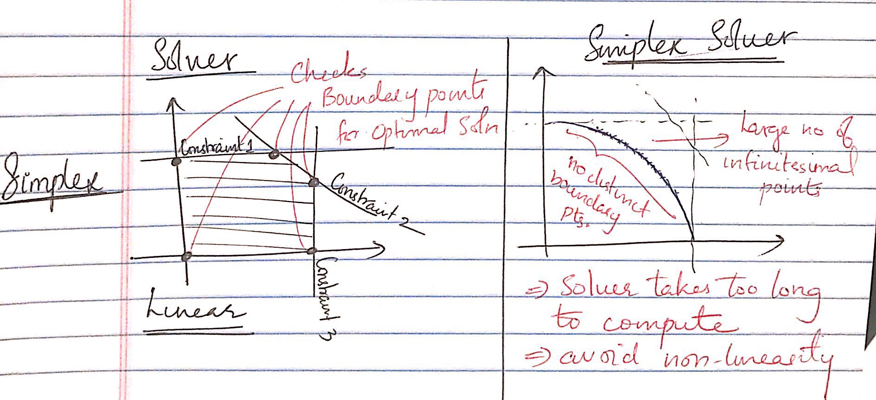

A maximum revenue of $75000 can be attained by allocating each of the checmicals to each of the chocolates as follows, and running processes 1 and 2 as shown below.

